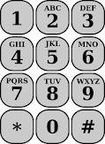

Spelling Word Texting – Use the keypad to change all of your words into numbers!

1. _________________________ = ___________________

(word) (number)

2. _________________________ = ___________________

3. _________________________ = ___________________

4. _________________________ = ___________________

5. _________________________ = ___________________

6. _________________________ = ___________________

7. _________________________ = ___________________

8. _________________________ = ___________________

9. _________________________ = ___________________

10. ________________________ = ___________________