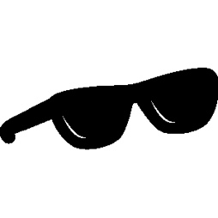
End of the Year
Scavenger Hunt

Find something in your room that is a rectangle. What is it? | Find something that is a cylinder in the kitchen.  Draw a picture of that item here. | Find a non-fiction book. What is it titled? | Find a digital clock. What time does it show?
Find an animal outside. What animal did you find? | Find a noun outside. What is it? | Go on a walk outside. Tally the number of birds you saw. | Find something that makes a long a vowel sound in it. What is it?
Find an something in your kitchen that is opaque. What is it? | Find a fiction book. What is it titled? | Find something that makes a short e vowel sound. What is it? | Tell someone what your favorite part about first grade was. What did you share?

