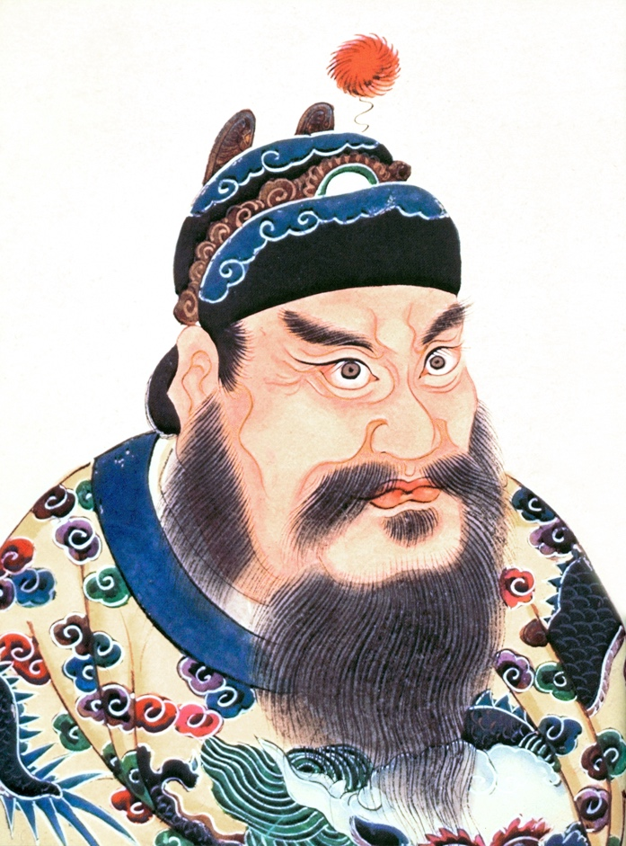

Emperor Qin Shi Huang, or Shi Huangdi, had many advisors who would be there to give him information and help him make decisions. However, Qin Shi Huang was not easy to advise since disagreeing with him could lead to severe, deadly punishment.

Imagine that you are an advisor to Qin Shi Huang during his 15-year reign. In a Google Doc with an MLA Heading, write him a letter to him advising him how to be a better leader for the people of China. In your letter, you must include:

1.Three examples about how he controlled China and his government style ______/6

2.Three examples about how he united China / standardization ______/6

3.Two examples about innovations / accomplishments of the Qin Dynasty for China _____/4

4. A letter opening and closing _______/2

5. Editing / no spelling or grammar mistakes / complete sentences ______/2

Total points ___________/20

Steps 1-2 due today
Full assignment due Monday by 5pm

Google Doc must be share with me today!

Some examples of what you might write in case you are stuck.

Since you have begun work on the Great Wall to protect our land from invaders, perhaps you might consider……….

The people are using the money you have chosen for our land, and……

China for the first time I united under one ruler, yet……

