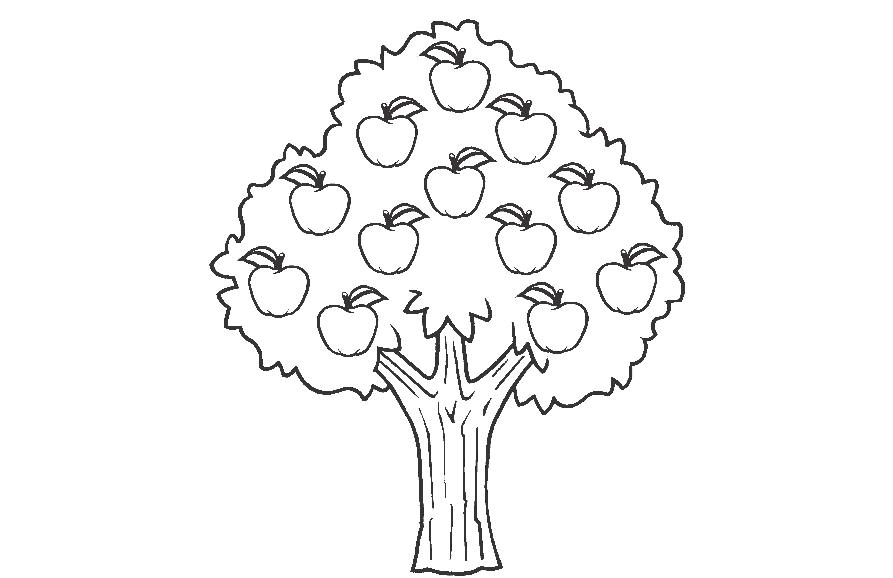

We rode home from school in the car.

**11 1**

**Grade 2 • Chapter 10** Time

**244**

half past 9

half past 10 half past 1

**F.**

**G. H.**

quarter past 1

quarter past 2 quarter til 2

**A.**

**B. C.**

**6**

**6**

**5**

**7**

**7 5**

**2**

**3**

**10**

**9**

**8**

**2**

**3**

**10**

**9**

**8**

**11 1**

**11 1**

**12**

**12**

**6.**

**5.**

**What time is shown on each clock? Circle the answer.**

**6**

**5**

**7**

**G.** 12:15 P.M.

**H.** 3:00 P.M.

**2**

**3**

**10**

**9**

**8**

3:00 A.M.

**F.**

**11 1**

**4.**

**12**

We read books.

**6**

**7**

**5**

**2**

**3**

**10**

**9**

**8**

5:10 A.M.

5:10 P.M.

2:25 P.M.

**A.**

**B. C.**

**11 1**

**3.**

**12**

We went swimming.

**6**

**5**

**7**

11:15 P.M.

2:55 P.M.

**2**

**3**

**10**

**9**

**8**

. .

11:15 A M

**F.**

**G. H.**

**2.**

**11 1**

**12**

We picked apples.

**6**

**5**

**7**

**2**

**3**

**10**

**9**

**8**

4:00 A.M.

4:00 P.M.

12:20 P.M.

**A.**

**B. C.**

**1**

**12**

**What time did each activity take place? Circle the answer.**

**Chapter Test, Form 1A**

Name



**.**

Name

**Chapter Test, Form 1A**

*(continued)*

**Read the clock. Circle the time.**

**F.**

**G. H.**

11:40

11:45

11:50

**7.**

**A.**

**B. C.**

7:15

7:25

7:35

**8.**

**12**

**12**

**11**

**1**

**11**

**1**

**10**

**9**

**8**

**10**

**9**

**8**

**2**

**3**

**2**

**3**

**7**

**5**

**7**

**5**

**6**

**6**

**9.**

**10.**

**A.**

**B. C.**

2:10

2:15

2:20

**F.**

**G. H.**

6:40

6:45

6:50

**12**

**12**

**11**

**1**

**11**

**1**

**10**

**9**

**8**

**2**

**3**

**10**

**9**

**8**

**2**

**3**

**7**

**5**

**6**

**7**

**5**

**6**

**Solve.**

**11.** Margo’s family went hiking at 10:15. They hiked for

2 hours. Then they stopped to eat lunch for 1 hour. What time did they finish lunch?

**A.** quarter til 1

**B.** quarter past 1

**C.** quarter past 2

**12.**

Carter is at home. Soccer

practice starts at 11:45. He has 3 hours to wait. What time is it now?

**F.**

**G. H.**

quarter til 8

quarter past 8 quarter til 9

**245**

**Grade 2 • Chapter 10** Time