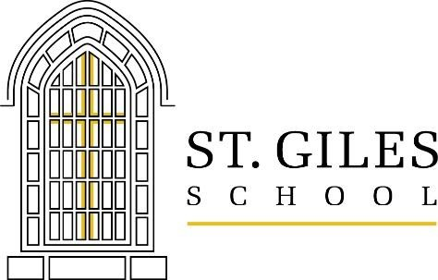 July 2021

At St. Giles, we believe in-person learning is essential for the intellectual, emotional, physical and spiritual growth of our students, so we are looking forward to being back to school for a “normal” year! St. Giles Parish School remains a vibrant and valued member of the Oak Park community. Generations of students have passed through our halls and many remain in the community. The diverse student body includes young people from a broad range of ethnic and socio-economic backgrounds. St. Giles offers a wide range of after school activities including athletics, band and various clubs. It also offers before and after care for families.
In past years, we were able to rely on the support of the parish to help keep tuition affordable. Due to many factors, schools can no longer rely on the same level of parish support. Nonetheless, the cost of providing a quality education continues to rise. In the midst of this, our school continues to thrive and provide an outstanding faith-based education. Through the support of generous donors like YOU, we have been able to continue this tradition of excellence - developing young hearts, challenging minds, imparting responsibility and duty to their community and teaching social justice and the importance of serving others.
St. Giles School is seeking support from companies and individuals from our wonderful community. Last year, schools were challenged in ways never experienced and St. Giles remains committed to continuing the tradition of providing an outstanding education for their students, stronger than ever.
How can you help your business by helping St. Giles at the same time? Sponsorship. Through sponsorship, we will spread the good word about your organization to one of the largest school and parish communities in the area. Your business will be promoted at our two largest fundraising events:
- On September 30, over 350 students in PK – 8th grade will participate in our annual Lion’s Leap Fun Run.
- On March 19, 2022, more than 200 past & present school parents and community members will gather
in person for camaraderie in support of the school with live and silent auctions at the Black & Gold Pride.
Sponsors who make a verbal commitment by August 15 will have their logos printed on the upcoming Lion’s Leap 2021 t-shirts, distributed to over 400 students and faculty! Please review the enclosure for various sponsorship levels and donate as you are able.
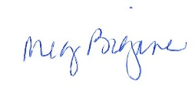
With gratitude,

Meg Bigane, Principal Kelly Richard, Development
St. Giles School . 1034 Linden . Oak Park . IL . 60302 . www.stgilesschool.org

